Use Case 2: Teacher

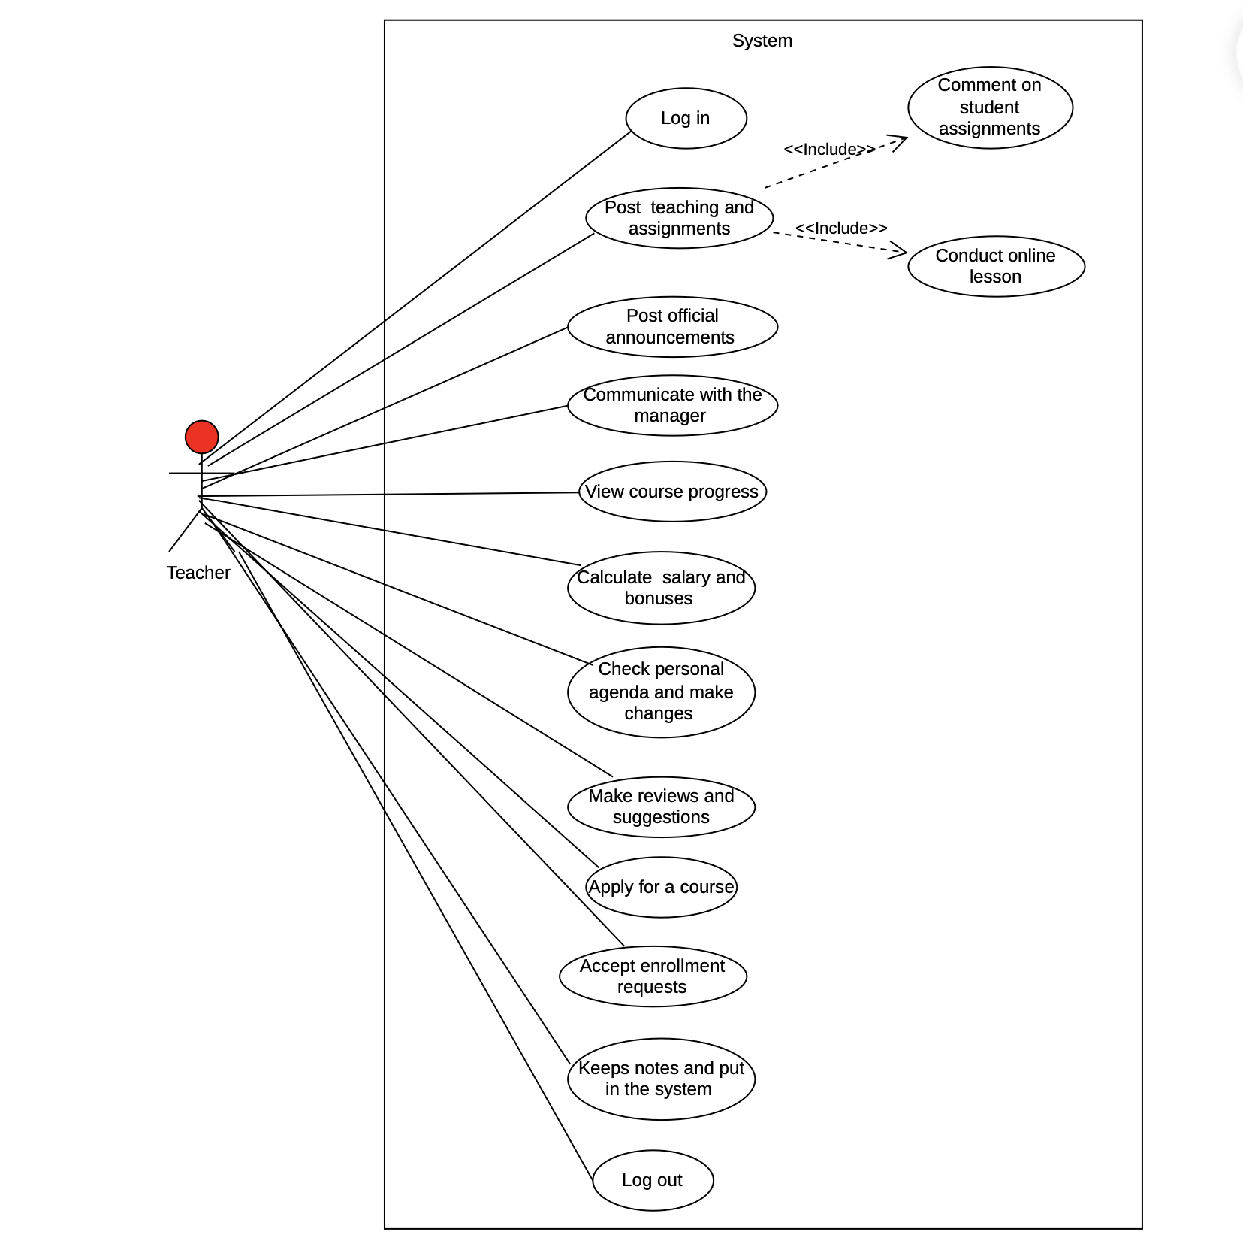

**4.Software Design**

**Teacher**

**S_T1: Teacher creates an account**

1. Teacher logs in to the app using their preferred way as a regular user.
2. By supplying the required extra fields, the administrator designates the

teacher's profile as an employee.

1. The Teacher's View is given to the teacher the next time she registers

in.

**S_T2: Teacher is not an employee of the center anymore.**

1. The teacher's account is removed from the list of employees by the administartor.

2. As a regular user, the teacher has access to the app.

**S_T3: Teacher opens the app as an already signed in user.**

1. The user's existence in the employee list is checked.

2. If the result is positive, the Teacher's particular View is displayed.

3. A dashboard comprising "My Agenda," " MyCourses," "My Services," My Notes&Suggestions" and “Communication Stream” is displayed to the teacher

**S_T4:Teacher apply to take the courses**

1. In the beginning of the year ,the teacher should apply to take the courses she/he will share.
2. On the Home screen ,Teacher accesses the Dashboard
3. Teacher taps “MyCourses”
4. The Teacher uses the floating bar to select the courses on each day of the current or coming week, then submits.
5. This information is given to the manager , who adapts the schedule to meet these requirements

**S_T5: Teacher views the personal agenda**

1. The user selects the “My Agenda” tab from the dashboard.
2. A tabbed interface containing “Today’s Schedule” ,“Schedule Changes” and “Post Announcement” is shown to the teacher.
3. On each tab the teacher will see a list of all changes of schedule and all the given notices ,sorted by tart time.

**S_T6:Teacher manages her students and lessons with assignments also.**

1. Teacher selects “My Courses” from the drop down menu.
2. A list of courses is displayed.
3. One of the records on the list is pressed by the teacher.
4. The selected course page with all the data is displayed
5. A teacher can conduct online lesson ,post assignments ,post teaching materials.

**S_T7: Teacher starts a new course and accept enrollment requests.**

1. The teacher selects a course.
2. The teacher selects the number of students in that class ,can accept or not if the class has started
3. The teacher selects the schedule together with the students.
4. The teacher fill out the link to create the online class for that course ,which the students will have access to that link
5. The teacher keep track of course progress and use a graphic chart to see the progress for each student registered in the course.
6. The individual lesson is assigned a price by the teacher ,which is then added to the total lesson cost.

**S_T8: Teacher keeps notes for every course and make reviews and suggestions**

1.Teacher selects “My Notes&Suggestions” from the drop down menu.

2.The teacher submits the review, suggestion, or proposal.

3.The manager receives the submission and reviews it.

4.The manager takes action on the submission, which may include implementing the suggestion or proposal, providing feedback to the teacher, or taking no action.

5.The teacher selects the class for which notes need to be taken.

6.The teacher takes attendance and marks the attendance of each student in the system.

7.The teacher records notes about the participation and engagement levels of each student in the system.

**S_T9: Teacher communicate with the manager to provide information regarding the courses, the presence, and to ask questions**

1.The teacher selects “Communication Stream” from the drop down menu.

2. The teacher drafts a message, including the required details and/or the appropriate question(s).

3. The management receives the message from the teacher.

4. The manager gets and reads the communication.

5. The management writes a rejoinder and sends it to the teacher

6. The teacher reads the response after receiving it.

**S_T10: Teacher controls her salary and bonuses**

1.The teacher selects “My services” from the drop down menu.

2.The salary and bonus computation page is displayed by the system.

3.The teacher enters their work schedule, any overtime, vacations, and other pertinent information.

4.The system uses the entered information to determine the teacher's pay and bonuses.

5.The teacher can observe the system's calculated compensation and bonuses.

6.The teacher confirms the pay and benefits.

|  |  |
| --- | --- |
| Use Case_2.1 | Log in |
| Summary | This use case describes the process of logging into the online course management system for teachers. |
| Dependency | None |
| Actors | Primary actor:Teacher |
| Preconditions | -The teacher must download the application  -The teacher must have valid login credentials for the online course management system. |
| Description of the Main Sequence | -The teacher accesses the course management system's login page.  - The teacher is prompted by the system to input their username and password, which serve as login information.  - The user inputs their login information.  -The system checks the login information.  -The system logs the teacher into their account and displays the dashboard if the login information is accurate.  -The system displays an error message and asks the teacher to reenter their login information if the login credentials are invalid. |
| Description of the Alternative Sequence | If the system is unable to verify the login credentials due to technical issues, it displays an error message and prompts the teacher to try again later. |
| Non functional requirements | Performance: The system must be able to verify login credentials within 5 seconds.  Security: The system must use secure encryption protocols to protect the teacher's login credentials and personal information. |
| Postconditions | If the main sequence has been followed, the teacher is successfully logged into their account and can access the dashboard. |

4.3 Use Cases Extended

|  |  |
| --- | --- |
| Use Case_2.2 | Post Teaching and Assignments |
| Summary | Once logged in, the teacher visits the course page and adds readings, assignments, and other resources for her students to access. She sends an invitation to every student enrolled in the course as well as sets an online lesson or meeting for the following day. |
| Dependency | This use case depends on the successful completion of the "Login" use case and also includes the use case 2.3 and use case 2.4 |
| Actors | Primary Actor: Teacher  Secondary Actor: Students |
| Preconditions | The user is logged into the system.  The teacher is enrolled as an iteacher for the course.  The course has already been created and enrolled with the students. |
| Description of the Main Sequence | - The user accesses the course page.  - The teacher determines whether or not to post learning resources.  - The teacher either creates the materials personally or uploads them to the system.  - The assignments are made by the teacher and published on the course page.  -The teacher decides to arrange an online lesson.  -The teacher invites all enrolled students to the lesson and chooses the day and time for it.  -The teacher checks and verifies the readings, assignments, and syllabus. |
| Description of the Alternative Sequence | - If the teacher encounters any technical issues, she contacts the technical support team.  -If the teacher is not enrolled as a teacher for the course, she contacts the administrator. |
| Non functional requirements | -Performance: The system must be able to handle the uploading and storage of large files, as well as the scheduling of online lessons and invitations to all enrolled students.  -Security: The system must ensure the confidentiality and integrity of the uploaded teaching materials, assignments, and online lesson information. |
| Postconditions | -Teaching materials and assignments have been successfully posted on the course page.  -An online lesson has been scheduled and an invitation has been sent to all enrolled students. |

|  |  |
| --- | --- |
| Use Case _2.5 | Post Official Announcement |
| Summary | This use case describes how to post formal announcements on the course page to let students know about any unforeseen circumstances. |
| Dependency | This use case depends on the successful completion of the "Login" use case. |
| Actors | -Primary Actor: Teacher  -Secondary Actor: None |
| Preconditions | -The teacher must be logged into the system.  -The teacher must have access to the course page where the announcement is to be posted. |
| Description of the Main Sequence | -The teacher navigates to the website for the course where the notice must be posted.  -The teacher selects "Post Announcement" from the menu.  -The system launches the form for creating announcements.  -The announcement's title, description, and date are filled in by the teacher.  -The notification is published on the course page by the teacher by clicking the "Post" button.  -The announcement is saved by the system, and the software displays it on the course page. |
| Description of the Alternative Sequence | In case the teacher encounters any technical issue while posting the announcement, she may retry posting the announcement or seek technical support. |
| Non functional requirements | -Performance: The system must be able to post the announcement within 10 seconds of clicking the "Post" button.  -Security: The system must authenticate the teacher before allowing her to post the announcement to ensure that only authorized personnel can post announcements. |
| Postconditions | The official announcement is published on the course page.  The students enrolled in the course can view the announcement on the course page. |

|  |  |
| --- | --- |
| Use Case_2.6 | Communicate with the manager |
| Summary | Teacher needs to communicate with the manager to provide information regarding the courses, the presence, and to ask questions. She sends a message through the designated communication stream to the manager and waits for a response. |
| Dependency | None |
| Actors | * Teacher (primary actor) * Manager (secondary actor) |
| Preconditions | * The teacher is logged in to the communication platform. * The manager is available to receive and respond to messages. |
| Description of the Main Sequence | -The teacher navigates to the communication stream designated for communicating with the manager.  -The teacher composes a message, providing the necessary information and/or asking the question(s).  -The teacher sends the message to the manager.  -The manager composes a response and sends it back to the teacher (if already logged in in the app). |
| Description of the Alternative Sequence | If the manager is not available to receive and respond to messages, the chat will remain open, unless the teacher chooses to end the chat.  If the manager does not respond in a timely manner, the teacher may need to send a follow-up message or use another method of communication to reach the manager. |
| Non functional requirements | -Performance: The communication platform should be reliable and responsive, allowing messages to be sent and received in a timely manner.  -Security: The communication platform should be secure and protect the privacy of the messages being sent. |
| Postconditions | The teacher has successfully communicated with the manager and received a response, or has sent a follow-up message or used another method of communication to reach the manager. |

|  |  |
| --- | --- |
| Use Case_2.7 | View Course Progress |
| Summary | The teacher is able to view the progress of each individual student and of the class in general. She checks how her students are doing and identifies areas where they may need additional support. |
| Dependency | None |
| Actors | Primary actor: Teacher |
| Preconditions | The teacher must have access to the course management system.  The teacher must be logged in to the course management system. |
| Description of the Main Sequence | -The teacher navigates to the course progress section of the course management system.  -The teacher selects the class or individual student she wants to view progress for.  -The system displays the progress report for the selected student or class.  -The teacher reviews the progress report and notes areas where additional support may be needed. |
| Description of the Alternative Sequence | - |
| Non functional requirements | Performance: The system must display progress reports in a timely manner.  Security: The system must ensure that progress reports are only accessible to authorized users. The visibility for this section of the app will be restricted. |
| Postconditions | The teacher has reviewed the progress report and identified areas where additional support may be needed |

|  |  |
| --- | --- |
| Use Case_2.8 | Calculate salary and bonuses |
| Summary | This use case describes the process of calculating the salary and bonuses for a teacher using the online system. The teacher inputs various factors, such as working hours, overtime, bonuses and paid leaves to determine their salary for the month. |
| Dependency | - |
| Actors | Primary actor: Teacher |
| Preconditions | The teacher has a valid and active account in the online system.  The teacher has worked for the current month and is eligible for payment. |
| Description of the Main Sequence | -The teacher logs into the online system.  -The system displays the salary and bonus calculation page. There will be an online automatic calculator in case the teacher would like to have a preview of the final sum they expect to receive.  -The teacher inputs their working hours, overtime, holidays, and any other relevant factors.  -The system calculates the teacher's salary and bonuses based on the inputted factors.  -The system displays the calculated salary and bonuses to the teacher. The user may choose to save this record or just leave it as a draft. |
| Description of the Alternative Sequence | -If the teacher encounters an error while inputting their information, the system displays an error message and prompts the teacher to re-enter the information. |
| Non functional requirements | -Performance: The system should be able to calculate the salary and bonuses accurately and efficiently within a reasonable time frame (in optimal conditions, it is estimated that this operation should be completed in no more than 8 seconds).  -Security: The system should ensure the privacy and security of the teacher's personal and financial information. |
| Postconditions | The teacher's salary and bonuses for the current month are calculated and saved in the system. |

|  |  |
| --- | --- |
| Use Case_2.9 | Check personal agenda and make changes |
| Summary | The teacher checks her personal agenda and makes changes to the schedule in cases where the class cannot be conducted in a certain time interval. She updates the online system with the new schedule. |
| Dependency | This UC depends on the system having a personal agenda feature (timetable) and a functionality to update schedules. |
| Actors | Teacher |
| Preconditions | -The teacher is logged in to the online system.  -The teacher has a need to change the schedule due to unavoidable circumstances (bad weather condition, health-related issues, etc). |
| Description of the Main Sequence | -The teacher navigates to her personal agenda feature on the online system.  -The teacher reviews her schedule for the upcoming weeks.  -The teacher identifies the exact time interval she would like to postpone or cancel.  -The teacher selects a new date and time for the class.  -The teacher updates the online system with the new schedule.  -The online system sends a notification to the students regarding the change in schedule. |
| Description of the Alternative Sequence | -If the teacher does not review her schedule, she may miss a conflict or potential conflict in the schedule. If the teacher does not identify any conflicts, she does not need to make any changes to the schedule.  -If the online system fails to update with the new schedule, the use case is aborted. |
| Non functional requirements | Performance: The online system should be responsive to the teacher's requests, and the updates should be reflected immediately.  Security: The online system should have appropriate access controls to ensure only authorized users have access to the personal agenda feature. |
| Postconditions | -The teacher's personal agenda is updated with the new schedule.  -The students are notified of the change in schedule. |

|  |  |
| --- | --- |
| Use Case_2.10 | Make reviews and suggestions |
| Summary | The teacher submits reviews, suggestions, or proposals to the manager to improve the quality of courses and contribute to the development of the center. |
| Dependency | - |
| Actors | The teacher  The manager |
| Preconditions | The teacher has access to the designated sector to submit reviews and suggestions.  The manager has access to review and consider the submissions. |
| Description of the Main Sequence | -The teacher accesses the designated sector to submit a review, suggestion, or proposal.  -The teacher writes the content of the submission, providing specific details and examples as necessary. Not all of the data fields will be mandatory.  -The teacher submits the review, suggestion, or proposal.  -The manager receives the submission and reviews it.  -In this use case, only the person who collects the reviews, the manager, will be able to handle the data received. |
| Description of the Alternative Sequence | If the teacher encounters technical difficulties while accessing or submitting the review or suggestion, the teacher contacts technical support to resolve the issue. |
| Non functional requirements | The system must be able to handle a large number of submissions at any given time.  The system must maintain the confidentiality of the submissions and protect them from unauthorized access. |
| Postconditions | The teacher's submission has been received and is being considered by the manager. |

|  |  |
| --- | --- |
| Use Case_2.11 | Apply for a course |
| Summary | This use case describes the process of a teacher applying for a course by filling out an application form online and submitting it for review. |
| Dependency | - |
| Actors | Teacher |
| Preconditions | The teacher has access to the online application form.  The teacher has selected the course they wish to apply for. |
| Description of the Main Sequence | -The teacher logs into the online system and navigates to the course application form.  -The teacher fills out the required fields in the application form, including their personal information, contact details, and academic qualifications. In the options provided and generated by the system, only the subjects related to the expertise of the professor will be displayed as an option.  -The teacher selects the course/s for and provides any additional information required for the course application. This form will also provide the teacher with the feature to append or attach any other documentation such as: CV, qualifications, etc.  -The teacher submits the completed application form for review. |
| Description of the Alternative Sequence | -If the teacher encounters any difficulties filling out the form, they contact the system administrator for assistance. Throughout the entire process, the information contact will be provided, so that the user can also be directly supported by the respective staff.  -If the course they wish to apply for is not available, the teacher contacts the system administrator to inquire about the availability of the course or may write something in the section sector. |
| Non functional requirements | -Performance: The online system must be able to handle a large number of concurrent course applications without experiencing any delays or crashes.  -Security: The system must ensure the privacy and confidentiality of the teacher's personal and academic information. |
| Postconditions | The teacher's application form is submitted for review.  The system sends a confirmation message to the teacher acknowledging receipt of the application. |

|  |  |
| --- | --- |
| Use Case_2.12 | Accept Enrollment Requests |
| Summary | This use case involves the teacher accepting enrollment requests on behalf of the students and keeping a record of the number of students in the class. |
| Dependency | - |
| Actors | Teacher: Primary actor who initiates the use case.  Students: Secondary actors who request enrollment in the class. |
| Preconditions | -The teacher is authorized to accept enrollment requests for the class.  -The class has available spots for enrollment. |
| Description of the Main Sequence | -The teacher receives an enrollment request from the manager of the system. After a student has signed the enrollment contract with our institution and contacted the staff for their decision about the program they would like to pursue, the manager sends to the teacher an enrollment request.  -The teacher checks if the class has available spots for enrollment.  If the class has available spots, the teacher accepts the enrollment request and adds the student to the class roster.  -The teacher updates the class roster with the new student's information.  -The teacher sends a notification to the student confirming their enrollment in the class.  -The teacher updates the record of the number of students in the class. The changes will be reflected in the database of the manager as well. |
| Description of the Alternative Sequence | If the class does not have available spots, the teacher rejects the enrollment request and notifies the student that the class is full through firstly having a conversation with the manager that administers the app. |
| Non functional requirements | -Performance: The use case must be executed within a reasonable time frame to ensure that the enrollment process is not delayed.  -Security: The enrollment information of the students must be kept secure and only accessible to authorized personnel. |
| Postconditions | The record of the number of students in the class is updated to reflect the new enrollment.  The student is either added to the class roster or notified that the class is full. |

|  |  |
| --- | --- |
| Use Case_2.13 | Keep notes and put in the system |
| Summary | The teacher keeps notes and inputs information about the participation of individuals in the lesson into the system, tracking attendance and engagement levels of each student. |
| Dependency | - |
| Actors | Teacher |
| Preconditions | The teacher has already conducted the lesson. |
| Description of the Main Sequence | -The teacher logs in to the system.  -The teacher selects the class.  -The teacher takes attendance and marks the attendance of each student in the system.  -The teacher records grades about the participation and engagement levels of each student in the system.  -The teacher saves the grades and attendance data in the system. |
| Description of the Alternative Sequence | - |
| Non functional requirements | -Performance: The system must be able to handle a large number of classes and students, and it should be able to save data in real-time without any delay.  -Security: The system should have appropriate access control mechanisms to ensure that only authorized personnel can view and modify data. |
| Postconditions | The attendance and engagement levels of each student are recorded in the system for the class conducted by the teacher. |

|  |  |
| --- | --- |
| Use Case_2.14 | Logout |
| Summary | This use case describes the process of logging out of the system by the teacher after completing her tasks for the day. |
| Dependency | - |
| Actors | Teacher |
| Preconditions | The teacher must be logged in to the system. |
| Description of the Main Sequence | -The teacher selects the "Logout" option from the system interface.  -The system confirms that the teacher wants to log out of the system.  -The system logs the teacher out of the system. |
| Description of the Alternative Sequence | - |
| Non functional requirements | -The system should log out the teacher within a reasonable amount of time, preferably less than 5 seconds. However, there may be a delay in case of a poor Internet connection or in case the performance of the device where the app is downloaded is not optimal.  -The system should be secure and ensure that unauthorized access is prevented during the log out process. |
| Postconditions | The teacher is logged out of the system and directed to the login page. |